Project: Causal Machine Learning
Students: Mert Kır, Sajjad Ayashm and Seppe Vanrietvelde
The analysis uses the pension data set of the hdm package. Table 1 shows treatment, outcome and covariates entering the causal model: employer provision of a 401(k) (binary A), household net financial assets (Y), and a block of demographic and economic controls (L) capturing income, family composition and other retirement vehicles.
Table 1: Variables, their role and descriptions of the pension dataset.
Role | Variable | Description
Treatment A | e401 | 1 = employer offers a 401(k); 0 = no offer
Outcome Y | net_tfa | Household net financial assets (USD)
Covariates L | age, inc, fsize, educ, marr, twoearn, db, pira, hown | Demographics, income, and other retirement vehicles

Question 1:
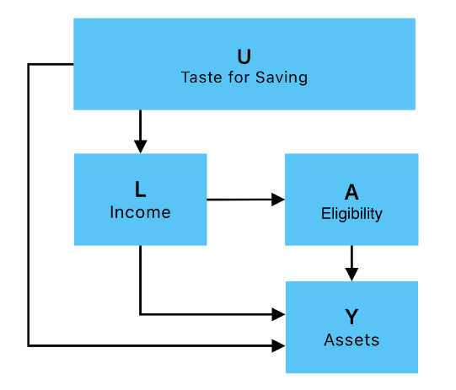
Late-1980s workers chose jobs based mostly on the income (U -> L) and not on eligibility for 401(k) (absence of U -> A) as there was no knowledge about the program. So, whether their employer already offered a 401(k) plan (the eligibility) was effectively a firm policy matter and had nothing to do with the individual workers behavior (which includes saving preference), which is unobserved. It can be expected that both individual behavior and income will have effects on the accumulated assets (U -> Y and L -> Y) and that there is probably some correlation between the income of a job and the eligibility for 401(k) (L -> A).
Figure 1: Causal DAG of the situation.
In the DAG (Fig. 1) it can be seen that it is not possible to assume that the unadjusted effect of A on Y is a causal effect because of the back-door path A ← L ← U → Y. Once income is adjusted for, that path is broken and 401(k) eligibility A is no longer conditional on potential assets Y(a). Hence, eligibility can be said to be randomly distributed within income groups, and any remaining difference in assets between eligible and ineligible workers is due to the causal effect of eligibility.

Question 2:
To eliminate the causal impact of eligibility, asset levels are estimated by a doubly robust cross-fitted Augmented Inverse-Probability Weighting (AIPW) estimator of the average treatment effect (ATE). The estimation is done through the ate function in the npcausal package with ensemble models and compared with an unadjusted analysis (Tab. 2).
Table 2: Results (and confidence intervals) of estimating the effect of eligibility on net financial assets through an unadjusted analysis and through usage of AIPW while conditioning on L.
Estimator | Estimate (USD) | 95 % CI (USD)
Unadjusted mean difference | 19 559 | 17 000 – 22 119
Cross-fitted AIPW (ATE) | 7 421 | 4 983 – 9 859

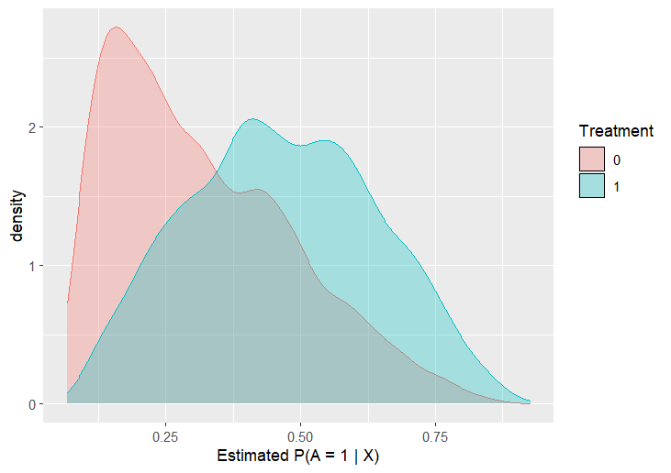
Controlling for the other covariates and income reduces the observed effect of 401(k) eligibility from almost $20 000 (naïve mean difference) to around $7 000 (cross-fitted AIPW). The 95 % confidence interval for the adjusted estimate, $4 983 –$9 859, excludes zero, which indicates a statistically significant positive effect. So employer sponsorship of a 401(k) is associated with a small but meaningful boost to family financial wealth, while most of the raw gap results from underlying "saver-type" characteristics already measured by the covariate set. Standard diagnostics confirm adequate overlap of propensity scores and no weights large enough to dominate the result (Fig. 2, 3).
Figure 2: Distribution of estimated propensity scores for eligible and non-eligible people.
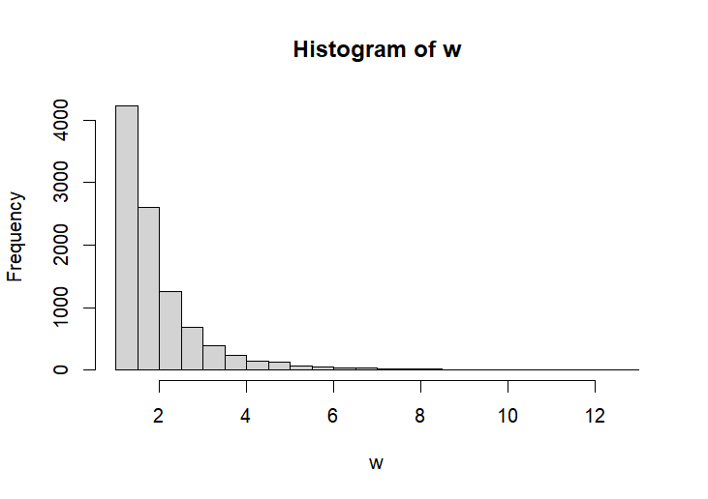
Figure 3: Histogram of AIPW weights.

Question 3:
Another way is to check if $θ= E \{Cov(A, Y |L)\} = 0$. This is again done through AIPW but now manually using the given efficient influence curve $\{A - E(A|L)\} \{Y - E(Y |L)\} – θ$. $E(A|L)$ and $E(Y|L)$ are estimated through superlearner with ensemble models an 5 fold cross-fit (Tab. 3).
Table 3: Results of estimating $E \{Cov(A, Y |L)\}$ through AIPW.
Quantity | Value
$$\hat{θ}$$ | 1086
95 % CI | 737 - 1434
Two-sided p-value | 1.01e-09

The estimated covariance is significantly different from zero, again indicating that there is a causal effect of eligibility on accumulated net financial assets.

Question 4:
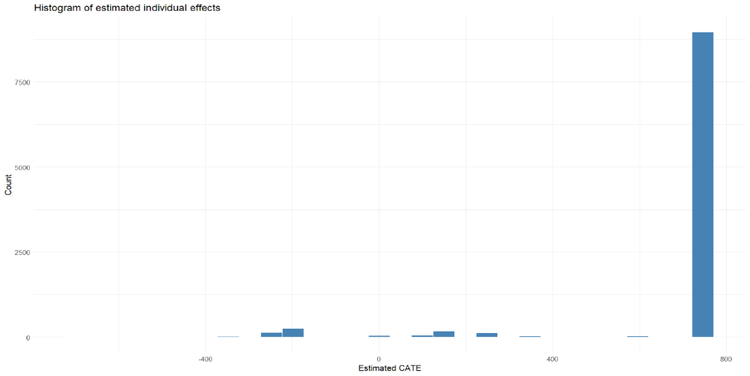
When we fit the R-learner using only age, income, and years of education as effect modifiers, we find that for the vast majority of observations, the estimated conditional average treatment effect (CATE) is tightly clustered around $720 (Fig. 4). The lack of substantial heterogeneity suggests those three covariates alone do not meaningfully modify the treatment effect.
Figure 4: Histogram of estimated conditional average treatment effects for all individuals.
Only for a handful of individuals, where the specific combination of age, income, and education diverges enough the model predicts a CATE that departs from $720. We can say that, conditional on age, income, and education, making a worker eligible for a 401(k) plan is estimated to increase their accumulated net financial assets by about $720 on average.

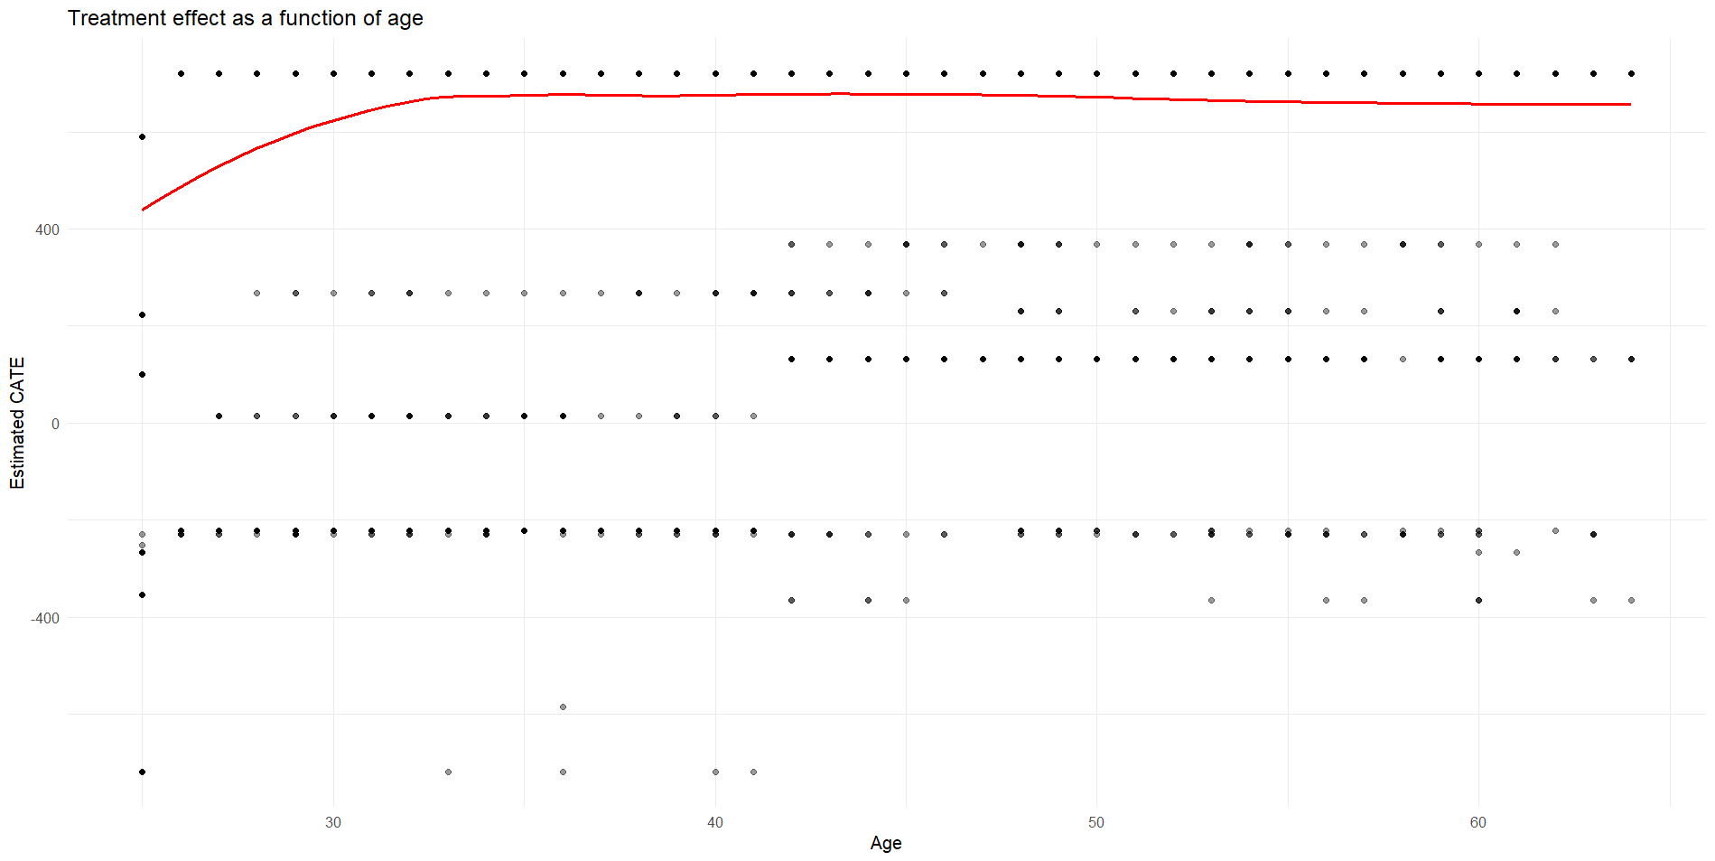
Fig. 5 shows a clear upward trend in the mid‐20s through early 30s, indicating that eligibility for a 401(k) has a growing impact on net financial assets as individuals progress from their mid‐20s to early 30s. After approximately age 35, the smoothed CATE curve levels off, implying that additional increases in age beyond that point do not materially change the average causal effect of eligibility.
Figure 5: Scatter plot with smoother of the estimated CATE in function of age for all individuals.
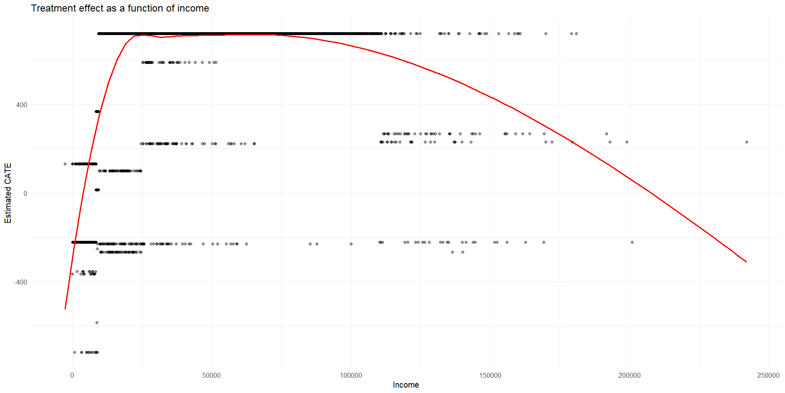
From Fig. 6 we can see that for people with less income (e.g. < $10.000), average treatment effect is smaller. We can say a similar thing for people with larger income, treatment effect for these people seems to be declining. Concretely, eligibility appears to have the smallest or even slightly negative impact for the poorest households, peaks in the middle‐income range, and then gradually decreases for those earning above $110.000. This pattern suggests that middle‐income workers gain the most from plan eligibility
Figure 6: Scatter plot with smoother of the estimated CATE in function of income for all individuals.
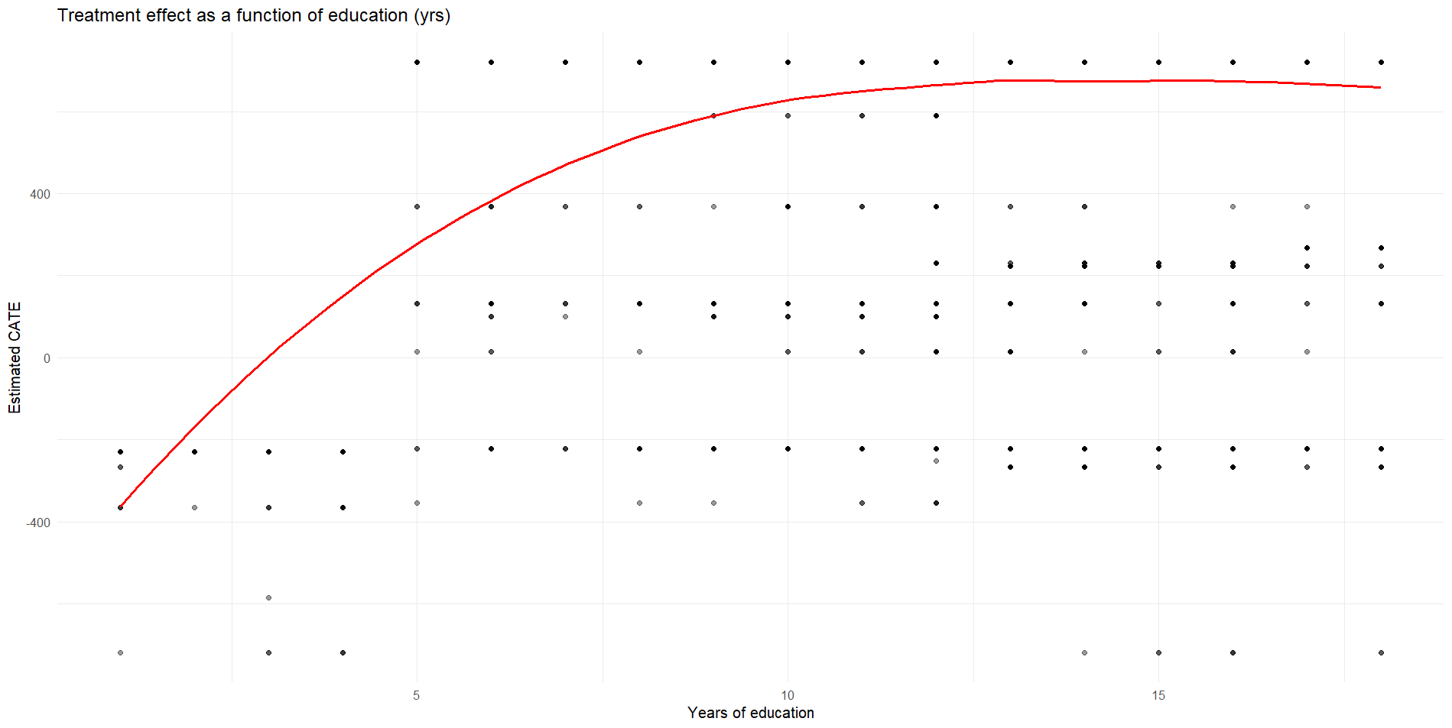
From Fig. 7 we can see that individuals with less than 5 years of education actually exhibit negative estimated effects of 401(k) eligibility, suggesting that eligibility may have had little or even adverse impact on their net assets. Individuals with more than 5 years see increasing positive effects, peaking at roughly 12 years of education (the typical threshold for high‐school completion).
Figure 7: Scatter plot with smoother of the estimated CATE in function of years of education for all individuals.

Question 5:
The counterfactual net financial assets that would be observed when being eligible for enrolling in a 401(k) plan can be predicted in function of age, income and years of education (controlling for age, income, family size, years of education, a married indicator, a two-earner status indicator, a defined benefit pension status indicator, an IRA (individual retirement account) participation indicator, and a home ownership indicator) using DR-learner.
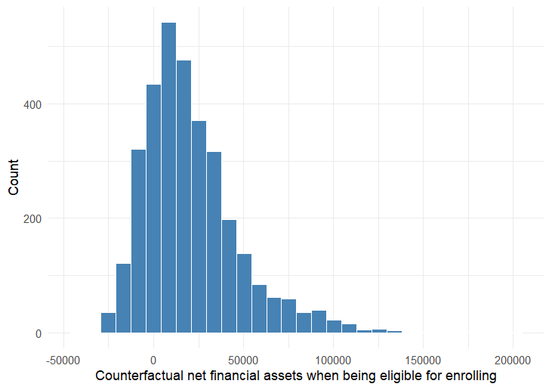
The estimated distribution of the net financial assets if everyone in the study was eligible for 401(k) is shown in figure . It takes values between -50000 and 200000 USD with most people around a few thousand USD. The overall distribution is somewhat skewed to the positive side.
The obtained estimates can be wrong. As such, the counterfactual prediction error $E\left\{{\left(Y^{1}- {\hat{Y}}^{1}\right)}^{2}\right\}$ can be estimated through AIPW. The resulting counterfactual prediction error is 2778967855 with a 95% confidence interval of [1036506632; 4521429078]. This result is probably wrong due to errors in the code.
Figure 8: Histogram of estimated counterfactual net financial assets when eligible for enrolling in 401(k).
Task division:
Sajjad Ayashm took initiative in question 1 through 3, Mert Kır took initiative in question 4 and Seppe Vanrietvelde took initiative in question 5. All group members reviewed each other’s work.

